Ventnor City Cultural Arts Center
Young Peoples Summer Art Program
ART CAMP at the Beach!
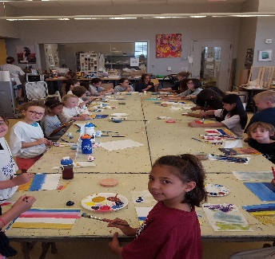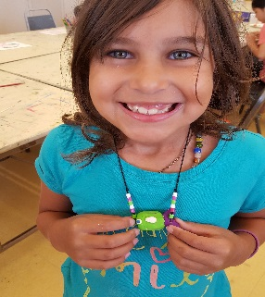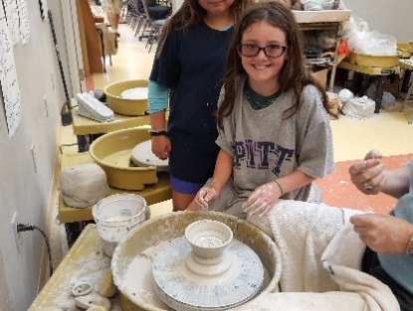
For kids ages 6- 12 only
One week sessions Mon.- Fri. 9am til 12 noon
July 1st- 5th –(off on 4th) - ART 101 - with Nancy La Re
July 8th -12th - - Fun with Clay- Sue Van Duyne Hunter OR
- Dance & Tumbling Camp –with Miss Gina
July 15th -19th – Fun with Clay with Jana Keeley OR
- Dance & Tumbling Camp - Miss Gina Palmer
July 22st - 26^{th- -} Crafts of all Kinds !! with Nancy La Re
July 29th- Aug.2nd - Mosaics with Michele Pasciullo
Aug. 5th-9th – Painting Down the Shore &More!- with Arica Cykiert
$150 per week Pre Registration is REQUIRED -NO WALK INS !
2019 Summer Art Camp Registration

Childs Name - _______________________
Parents Name - _______________________
Address - ____________________________
Phone - _______________/back up_______________
Email _______________________________
Check which camp / week
1.July 1st -5th Art 101 ( off july 4 ) ________ ($30 less)
2.July 8th -12th - Fun With Clay or ________
- Dance &Tumbling ________
3.July 15^{h} -19th - Fun With Clay or ________
-Dance &Tumbling ________
4.July 22rd -26th - Crafts of All Kinds ________
5.July 29 - August 2nd - Mosaics ________
6.August 5th-9th Painting Down the Shore _________ Total payment _________ PD _______

