Ventnor City Cultural Arts Center
Young Peoples Summer Art Program
ART CAMP at the Beach!
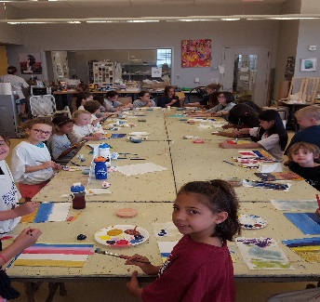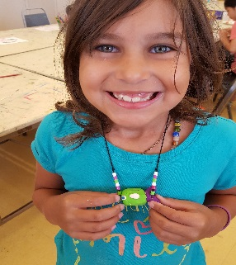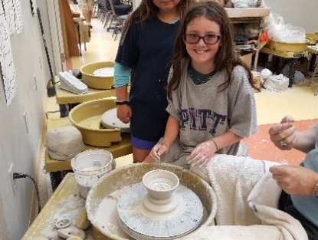
For kids aged 6- 12 only- Call (609)-823-7952 One week sessions, Mon.- Fri. 9am until 12 Noon
1. July 3rd -7th - Collage & Mixed Media (only 4 days- $35 less)
2. July 10th -14th – Fun with Clay With Jason & Sue OR…
- Dance & Tumbling – Ms. Gina Palmer
3. July 17th -21st ⁻ Crafts of all Kinds !! with Nancy La Re OR….
- Dance & Tumbling – Ms. Gina Palmer
4.July 24^{h}- 28th - Sculpture / 3D Art – with Nancy & Robin
5.July 31st-Aug 4th- ART 101- painting and drawing- with Nancy
6.August 7^{th-} 11th – Painting Down the Shore & more - with Nancy
$175 per week Pre Registration is REQUIRED - NO WALK- INS !
2023 Summer Art Camp Registration
Childs Name - _______________________
Parents Name - _______________________
Address - ____________________________
Phone - _______________/back up_______________
Email _______________________________
Check which camp / week
1.. July 3rd -7th – Collage & Mixed Media or ________ ($35 less)
2.July 10th -14th - Fun With Clay or ________
-Dance &Tumbling ________
3.July 17th- 21st - Crafts of All Kinds or ________
-Dance &Tumbling --------------
4.July 24th - 28th - Sculpture /3D Art ________
5. July 31st -Aug 4 ^{th} - Art 101 _______
6. August 7th-11th Painting Down the Shore _______

Total payment _________ PD _______

